Nama : Adridinan Najmi Faza
NIM :H1D025059
Shift Awal/Akhir : B/H
Test Awal
1. Tunjukan print screen hasil semua table pada skema order entry, total 6 table.
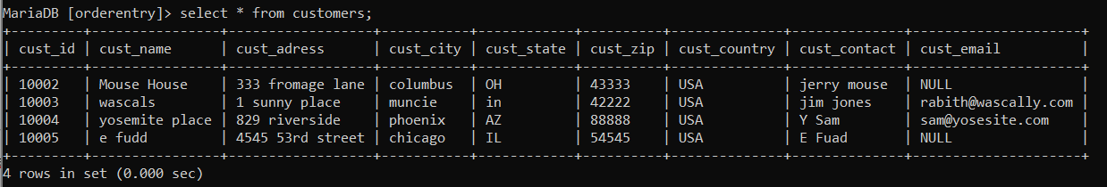
MariaDB [orderentry]> select * from customers;
+---------+----------------+------------------+-----------+------------+----------+--------------+--------------+---------------------+
| cust_id | cust_name | cust_adress | cust_city | cust_state | cust_zip | cust_country | cust_contact | cust_email |
+---------+----------------+------------------+-----------+------------+----------+--------------+--------------+---------------------+
| 10002 | Mouse House | 333 fromage lane | columbus | OH | 43333 | USA | jerry mouse | NULL |
| 10003 | wascals | 1 sunny place | muncie | in | 42222 | USA | jim jones | rabith@wascally.com |
| 10004 | yosemite place | 829 riverside | phoenix | AZ | 88888 | USA | Y Sam | sam@yosesite.com |
| 10005 | e fudd | 4545 53rd street | chicago | IL | 54545 | USA | E Fuad | NULL |
+---------+----------------+------------------+-----------+------------+----------+--------------+--------------+---------------------+
4 rows in set (0.000 sec)
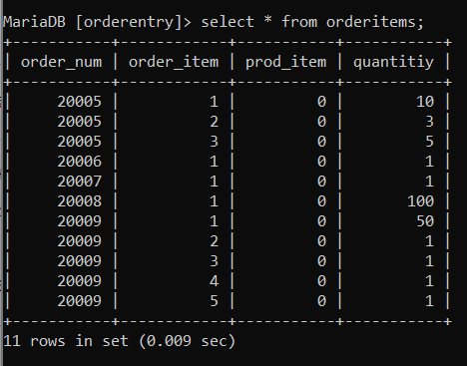
MariaDB [orderentry]> select * from orderitems;
+-----------+------------+-----------+-----------+
| order_num | order_item | prod_item | quantitiy |
+-----------+------------+-----------+-----------+
| 20005 | 1 | 0 | 10 |
| 20005 | 2 | 0 | 3 |
| 20005 | 3 | 0 | 5 |
| 20006 | 1 | 0 | 1 |
| 20007 | 1 | 0 | 1 |
| 20008 | 1 | 0 | 100 |
| 20009 | 1 | 0 | 50 |
| 20009 | 2 | 0 | 1 |
| 20009 | 3 | 0 | 1 |
| 20009 | 4 | 0 | 1 |
| 20009 | 5 | 0 | 1 |
+-----------+------------+-----------+-----------+
11 rows in set (0.009 sec)
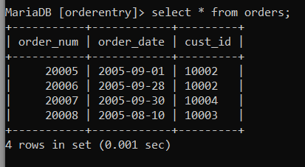
MariaDB [orderentry]> select * from orders;
+-----------+------------+---------+
| order_num | order_date | cust_id |
+-----------+------------+---------+
| 20005 | 2005-09-01 | 10002 |
| 20006 | 2005-09-28 | 10002 |
| 20007 | 2005-09-30 | 10004 |
| 20008 | 2005-08-10 | 10003 |
+-----------+------------+---------+
4 rows in set (0.001 sec)
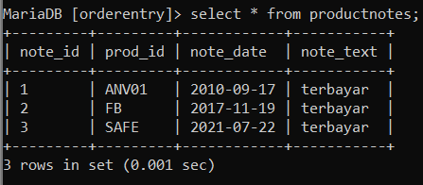
MariaDB [orderentry]> select * from productnotes;
+---------+---------+------------+-----------+
| note_id | prod_id | note_date | note_text |
+---------+---------+------------+-----------+
| 1 | ANV01 | 2010-09-17 | terbayar |
| 2 | FB | 2017-11-19 | terbayar |
| 3 | SAFE | 2021-07-22 | terbayar |
+---------+---------+------------+-----------+
3 rows in set (0.001 sec)
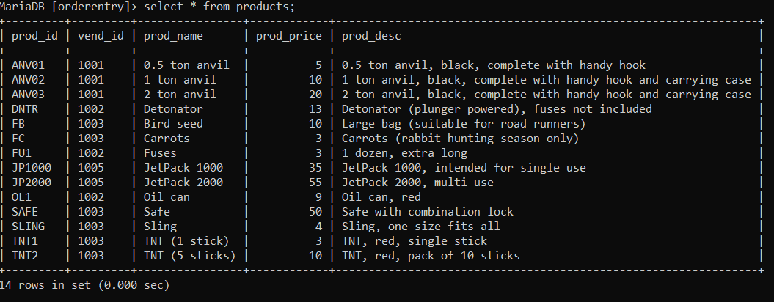

MariaDB [orderentry]> select * from products;
+---------+---------+----------------+------------+----------------------------------------------------------------+
| prod_id | vend_id | prod_name | prod_price | prod_desc |
+---------+---------+----------------+------------+----------------------------------------------------------------+
| ANV01 | 1001 | 0.5 ton anvil | 5 | 0.5 ton anvil, black, complete with handy hook |
| ANV02 | 1001 | 1 ton anvil | 10 | 1 ton anvil, black, complete with handy hook and carrying case |
| ANV03 | 1001 | 2 ton anvil | 20 | 2 ton anvil, black, complete with handy hook and carrying case |
| DNTR | 1002 | Detonator | 13 | Detonator (plunger powered), fuses not included |
| FB | 1003 | Bird seed | 10 | Large bag (suitable for road runners) |
| FC | 1003 | Carrots | 3 | Carrots (rabbit hunting season only) |
| FU1 | 1002 | Fuses | 3 | 1 dozen, extra long |
| JP1000 | 1005 | JetPack 1000 | 35 | JetPack 1000, intended for single use |
| JP2000 | 1005 | JetPack 2000 | 55 | JetPack 2000, multi-use |
| OL1 | 1002 | Oil can | 9 | Oil can, red |
| SAFE | 1003 | Safe | 50 | Safe with combination lock |
| SLING | 1003 | Sling | 4 | Sling, one size fits all |
| TNT1 | 1003 | TNT (1 stick) | 3 | TNT, red, single stick |
| TNT2 | 1003 | TNT (5 sticks) | 10 | TNT, red, pack of 10 sticks |
+---------+---------+----------------+------------+----------------------------------------------------------------+
14 rows in set (0.000 sec)
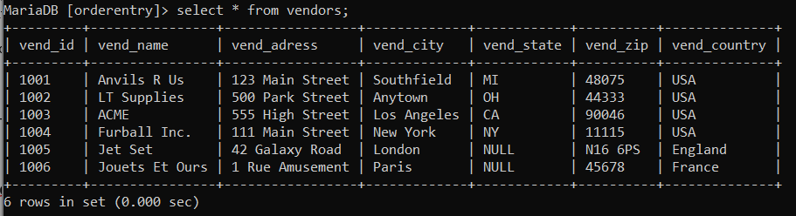

MariaDB [orderentry]> select * from vendors;
+---------+----------------+-----------------+-------------+------------+----------+--------------+
| vend_id | vend_name | vend_adress | vend_city | vend_state | vend_zip | vend_country |
+---------+----------------+-----------------+-------------+------------+----------+--------------+
| 1001 | Anvils R Us | 123 Main Street | Southfield | MI | 48075 | USA |
| 1002 | LT Supplies | 500 Park Street | Anytown | OH | 44333 | USA |
| 1003 | ACME | 555 High Street | Los Angeles | CA | 90046 | USA |
| 1004 | Furball Inc. | 111 Main Street | New York | NY | 11115 | USA |
| 1005 | Jet Set | 42 Galaxy Road | London | NULL | N16 6PS | England |
| 1006 | Jouets Et Ours | 1 Rue Amusement | Paris | NULL | 45678 | France |
+---------+----------------+-----------------+-------------+------------+----------+--------------+
6 rows in set (0.000 sec)

2. Sebutkan macam macam join yang anda ketahui
Inner Join, Outer Join, Left Join, Right Join, Self Join, Trigger, View

